|  | INTERNATIONAL TELECOMMUNICATION UNION  **TELECOMMUNICATION** **STANDARDIZATION SECTOR**  STUDY PERIOD 2022-2024 | | **Focus Group on AI Native Networks** | |
| --- | --- | --- | --- | --- |
| **AINN-I-xx** | |
| **Original: English** | |
| **Question(s):** | | N/A | Virtual, TBD 2024 | |
| **INPUT DOCUMENT** | | | | |
| **Source:** | | *SRM AP* | | |
| **Title:** | | *SRM Squad - Report on* *ITU WTSA Hackathon 2024 – The Golden Hour* | | |
| **Contact:** | | Mr. Ramu | | E-mail: [email@gmail.com](mailto:email@gmail.com) |

| **Abstract:** | This document contains the submission report for team name “SRM Squad” towards ITU WTSA Hackathon 2024 for use case *“The Golden Hour”.* |
| --- | --- |

## Use case introduction: **“The** G**olden hour”**

As per MoRTH [report](https://morth.nic.in/sites/default/files/AR-MoRTH_Annual%20Report_2023-24_English.pdf) , in 2022, 4,61,312 road accidents were reported, 1,68,491 persons were injured and 4,43,366 persons were injured. Govt of India initiated several schemes to provide timely care within the “golden hour” for accident victims. However, one of the important parameters is providing timely medical care to the victims of road accidents. This involves coordination between road traffic management systems as well as emergency management systems. Providing high quality care within the “golden hour” involves high priority connectivity to emergency care providers in the ambulance as well as in the emergency rooms.

Consider the scene map below:

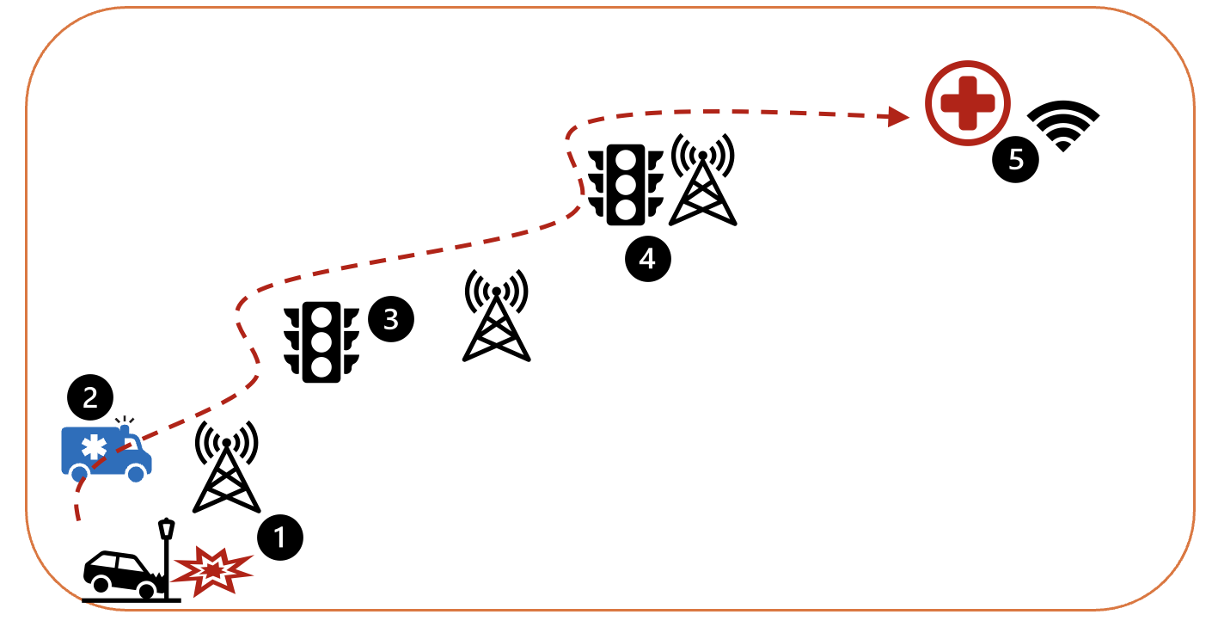

* Phase 1: Accident happens /Crash occurs. Mr. Ramu was driving in the highway when an unfortunate accident happens. Ramu is injured and the golden hour timer is starting. The concerned citizens call an ambulance.
* Phase 2: Ambulance arrives immediately. There is a medical team in the ambulance. The medical team starts first aid for Ramu and starts conversation with the emergency team in the ER (emergency room) and his vitals are monitored in real time.
* Phase 3: Traffic route is determined. Considering the golden hour rule, an optimal traffic route is determined. This also determines the connectivity on the way which should not break to avoid a break in monitoring of Ramu by the ER team.
* Phase 4: During the transit medical support is given. The team in the ambulance provides medical support and emergency help for Ramu during the transit with the support of the ER professionals.
* Phase 5: Emergency room is reached and local connectivity is used. Once the ER room is reached, Ramu is shifted to the ER and the enterprise connectivity in the ER is used.

Clause-3: PS1: pipeline design

* AI /ML Concept used is Mobility Prediction. The following pipeline design is used.

* SRC: UE locations
* C: edge servers
* M: mobility prediction, traffic predictions.
* D: rApp
* Sink: xApp

Clause-4: PS2: xApp design

* Open RAN concept used is Scaling and UE trajectory prediction-based mobility optimization. Scaling allows resources to be added (and deleted) based on the demand. In this case, based on the traffic route followed, the corresponding edge servers are provisioned on demand to allow seamless monitoring of the patient by ER doctors.

Clause-5: Relation to Standards.

Clause-6: Code submission details

Clause-7: Self-Testing results

_________________